CBOE Direct
System Health Monitor
Master Feature List

Prepared By:
Troy Wehrle

Version: 4.0
Last Saved: 9/28/2006 08:26:00 PM
Feature Priority Matrix
Feature | Page # | Priority | Time Estimate (Days)
Alarm Conditions – Calculated Instrumentors Evaluation | 8 | 1 | G-30; IC-40
Alarm Conditions – Evaluation against Previous States | 8 | 2 | G-5; IC-15
Derived Calculated Instrumentors | 9 | 3 | G-20; IC-60
Alarm Notification – Provide Full Event Contents | 13 | 4 | G-10; IC-10
Alarm Conditions – Additional Filters | 10 | 5 | G-10; IC-10
Table Cell Expanders | 14 | 6 | G-10
Filtering – Allow Multiple Cluster Selections for Filters | 9 | 7 | G-5
Graph – Memory Issues with Retaining Data | 12 | 8 | G-5
Graph – Multiple Graphs Tiled onto One Window | 12 | 9 | G-10
Defect – Allow exclusion and multiple filters in SHM (SYS004103) | 13 | 98 | G-8
Defect - ICS SHOULD PERFORM ACTIVATION VALIDATION (SYS004176) | 14 | 98 | IC-1
Defect - NOTIFICATION WATCHDOG TIMER SHOULD NOT BE SCHEDULED AT FIXED RATE (SYS004194) | 14 | 98 | IC-1
Access Control in GUI when ICS is absent | 13 | 99
Alarm Definitions – Provide Save As or Copy for an Alarm Definition | 10 | 99
Alarm Scope – Local | 4 | 99
Archiver Improvements in Infrastructure | 5 | 99
CAS Re-Inits – Add a Count Instrumentor | 10 | 99
Expand/Collapse All Nodes in a Tree | 9 | 99
Force a Re-Init of a CAS – Allow SHM-GUI to Initiate | 10 | 99
Force Logoff Users – Allow SHM-GUI to Initiate | 10 | 99
Graph – Printing or Exporting to External File | 11 | 99
Heartbeating | 4 | 99
ICS Admin Commands | 4 | 99
Instrument the Alarm Notification Watchdog | 11 | 99
Instrumentor Rollup to Cluster | 9 | 99
Modal Dialogs – Evaluate Removal | 10 | 99
New Instrumentors | 9 | 99
Performance Test Drivers, Improve | 11 | 99
Preference Files, User – Improve Implementation for Storing | 8 | 99 | G-3
Preference Files, User – Provide Individual Settings | 8 | 99 | G-5
Printing for all Tables | 10 | 99
Process Information – Add System Health Attributes | 7 | 99 | G-5
Process Watcher Status – Provide New States | 7 | 99 | G-5; C-15
Product Lookup Interface | 5 | 99 | G-1
Product Query Lookup – Dynamic Definition for SACAS | 5 | 99 | G-3
Product Query Lookup – Re-Initializing SACAS References | 5 | 99 | G-3
Standalone Mode | 13 | 99
System Summary Screen – Extended Navigation to Matching Alarm Entry | 7 | 99 | G-3
System Summary Screen – Provide Filtering | 7 | 99 | G-5
System Summary Screen – Re-Layout | 6 | 99
User Login Info Added to the CAS Monitor | 10 | 99
Version Number for CAS Missing until Subscribed | 10 | 99
XTP Logging Events | 12 | 99
G = GUI Resources; C = CAS Resources; I = Infra Resources; IC = ICS Resources

Alarm Scope – Local

Current Situation
All Alarms Notifications that are sent out from the ICS are delivered to all System Health GUI’s. It is not possible to specify that a particular Alarm Activation only be sent to a particular GUI application. During Alarm creation testing, this can be troublesome if someone creates an Alarm Condition that will constantly be evaluated to true and continually send Alarm Notifications.

Proposed Solution
We would like to add an aspect of locality to the Alarm Activations. It should be possible to designate Alarm Activations as Local or Global. Global would equate to what we have today. Local Alarm Activations would only be sent to the System Health GUI that asks for them. Local Alarm Activations should be removed when the GUI is shutdown.

ICS Admin Commands

Current Situation
The ICS does not have a way to dynamically configure its logging properties. It would also be nice if we could re-initialize the state of the ICS without causing all the connected GUI’s to restart.

Proposed Solution
We propose adding an Admin Commands interface to the ICS so that these things can be addressed. The logging properties would then be able to be dynamically configured. We could also force the ICS to cleanup user sessions, republish all data to everyone connected, cause it to internally restart, stop publishing alarm notifications (still process and log the alarms) and stop all alarm notification processing (no central logging).

Heartbeating

Current Situation
The initial version of the ICS watches for connected GUI’s to disappear by utilizing Process Watcher. This requires all connected GUI’s to be listed in the PW watch list. This is not very flexible for GUI installations. We use this information to allow the ICS to cleanup its session information and caches for a particular GUI.

Proposed Solution
We would like to have a way to allow the ICS to heartbeat back to the GUI’s for final determination when the GUI’s disappear.

Archiver Improvements in Infrastructure

Current Situation
The Infrastructure Archiver is not currently archiving the CAS’s queue instrumentors. It also has a problem writing out the user data that is embedded in the instrumentors. Things such as embedded CR/LF.

Proposed Solution
We would like Infrastructure to correct these problems in the Archiver.

Product Query Lookup – Dynamic Definition for SACAS

Current Situation
The Instrumentation data contains only class and product keys. We use a specific SACAS to resolve these keys to actual classes and products. This allows us to show more detail about the classes and products to the user. Currently, the user must hand edit a properties file to specify which SACAS they would like to use. We do not have a way for the user to specify this within the GUI interface itself.

Proposed Solution
We propose providing a selection screen so that the user can select from a choice of SACAS’s to use for resolving the class and product keys. This will allow our application to continue to work at its optimum if the original SACAS becomes absent.

Product Query Lookup – Re-Initializing SACAS References

Current Situation
Currently, if we fail in trying to resolve the class and product keys information in the Instrumentation data from the SACAS, we will consider the SACAS absent and not try again.

Proposed Solution
We propose providing a screen component to allow the user to gesture that they would like our application to refresh its state of the SACAS and try again to resolve class and product keys with it. This will allow our application to continue to work at its optimum if the original SACAS became absent for some reason previously, but has since been restored.

Product Lookup Interface
Include the existing Product Query Lookup dialog from our other applications in this application. This will allow a user who has only a product or class key to perform a query to display all relevant detailed information for those products or classes.

System Summary Screen – Re-Layout

Current Situation
The System Summary screen is limited to how many processes can be displayed at one time due to the layout of the screen.
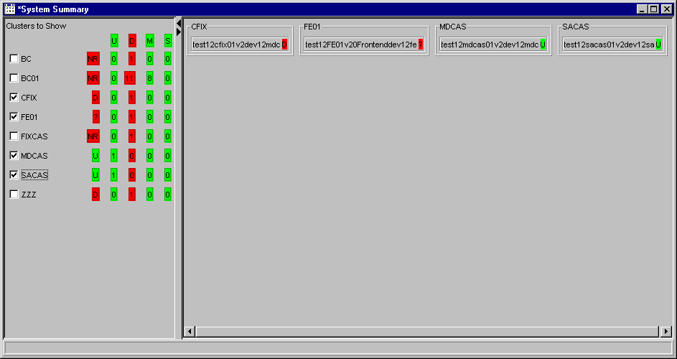

Proposed Solution
We propose changing the layout to provide a more compact display so that more processes can be displayed at one time on the screen.
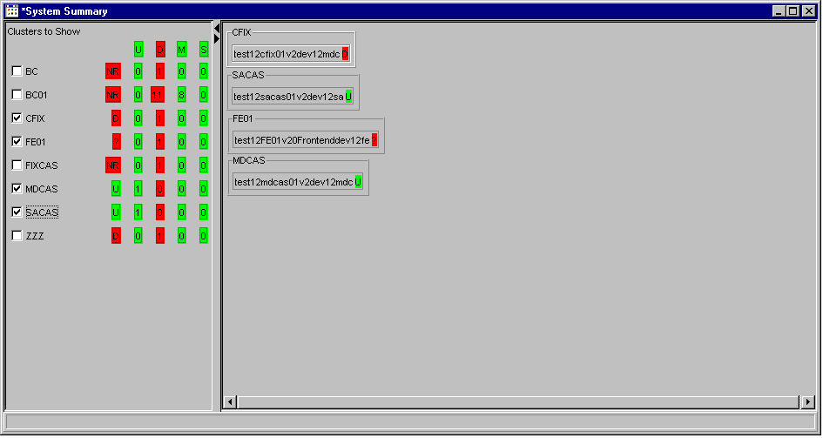

System Summary Screen – Extended Navigation to Matching Alarm Entry
When a summary process is selected in the tree navigation, clicking on one of the filtering options should scroll to view and select the first process that resulted in that matching the filtering option. While that item is selected, clicking on the filtering option again should scroll to view and select the next one.

System Summary Screen – Provide Filtering

Current Situation
The System Summary screen does not provide any functionality to filter out certain data.

Proposed Solution
Provide the same filtering functionality (Up, Down, etc.) to the System Summary screen. The user would also like to filter out certain ORB and/or group names.

Process Watcher Status – Provide New States

Current Situation
Currently the Process Watcher only keeps track of Up and Down states for a given process. When a processes state changes to Up, it is not an indication that the process is initialized and ready for business. It only indicates that the process does indeed exist as an OS live process. This state generally changes to Up, minutes before a process is actually finished initializing and ready for business. This can cause timing issues with trying to communicate with a given process based on the change of Process Watcher status.

Proposed Solution
We propose added a new state identifying the Ready/Initialized stage. This would have to be supported by Process Watcher and each process would need modified to set it appropriately.

Process Information – Add System Health Attributes

Current Situation
Currently the highlights for specific data alarm points are fixed colors and based on pre-determined, fixed values.

Proposed Solution
A proposal has been made to allow the user to designate the colors and/or patterns and threshold values to be set per individual process. These could be tied to the ORB aliases that we are allowing the user to set, as well as the users custom groupings.

Preference Files, User – Improve Implementation for Storing

Current Situation
The preference files are stored in a common location for all instances of the application to use. The current implementation cannot handle the creation of remote directories.

Proposed Solution
Extend the implementation to be able to create remote directories. This will facilitate the implementation of Individual User Preferences.

Preference Files, User – Provide Individual Settings

Current Situation
The preference files are stored in a common location for all instances of the application to use. The current implementation allows only one master GUI application to setup the preferences as desired. Every other GUI installation then reads this common preferences file and uses the same settings. This does not allow each user to have their own settings for ORB aliases and groupings, colors and/or patterning, threshold values for alarms, etc.

Proposed Solution
Allow a user to specify a profile of settings they would like to use. They may also create a new profile to save settings within. This would not require any specific login. The specification of a profile would be totally voluntary. We would save the settings in a specific file designated for that profile.

Alarm Conditions – Evaluation against Previous States

Current Situation
Alarm Conditions are only evaluated against the current state of the last event. We do not have a way to evaluate the current value against the previous value.

Proposed Solution
Provide a way to include the value of the previous condition state to be compared to the current condition state, for evaluation.

Alarm Conditions – Calculated Instrumentors Evaluation

Current Situation
Calculated Instrumentors are a feature within the SHM-GUI that provides rolled-up, or calculated summaries for the Instrumentation data. This allows the SHM-GUI to show summary info for groups of existing Instrumentation data. The ICS is not aware of these Calculated Instrumentors at all. The users would like to create Alarm Conditions base on these Calculated Instrumentors. Since the Alarm Condition evaluation is performed by the ICS and the GUI creates the Calculated Instrumentors, this is currently not possible.

Proposed Solution
To solve this, we would need to have the ICS create/calculate the Calculated Instrumentors and subject them to the Alarm Condition evaluation processing. This means that we need to modify ICS to handle calculated instrumentors, i.e. configure Infrastructure to turn calculations ON, modify all business models and wrappers to work with calculated fields, allow conditions to use calculated fields.

Derived Calculated Instrumentors

Proposed Enhancement
The user would like a way to create their own instrumentors that are the result of a mathematical calculation based on combination of N-other instrumentors and fixed values. These new “Derived Calculated Instrumentors” should be published as all existing instrumentors are published. This will allow them to be introduced to the existing functionalities for Alarm Processing, Charting, etc. The user would specify a name to call the instrumentor, a name to call the mathematical expression and the mathematical expression itself. We will have to decide later whether the calculations should be restricted to instrumentors from the same ORB or allow multiple ORB’s. If they included multiple ORB’s, we would need to decide how to display and publish them.

New Instrumentors
RT-Server Disconnect
CPU Utilization
Garbage Collection Summary

Expand/Collapse All Nodes in a Tree
User noted that this would be useful for looking at only subscribed processes. I believe the intention of this is to be able to select a node is such a way as to cause all its child nodes to be expanded. I am not sure about Collapse all though, because that can be achieved already by collapsing the appropriate node.

Filtering – Allow Multiple Cluster Selections for Filters
This would apply to the System Health screen.

Instrumentor Rollup to Cluster
Users Note: at least propagate the Alarms - but it would be useful to push up the "worst" instrumentors like queue, to cluster as well.

Version Number for CAS Missing until Subscribed
Users Note: I think the CAS is not putting version until sub; heap instrumentor has info but not pushed up.

Alarm Conditions – Additional Filters
It would be useful to have a filter on used/unused/all to indicate if the conditions have been used. This makes it easier to find items in a long list - which if cluster names are not added, will easily be in the hundreds, if not thousands.

Alarm Definitions – Provide Save As or Copy for an Alarm Definition
No additional details.

Modal Dialogs – Evaluate Removal
Users Note: Modal dialogs hurt - try to avoid them completely if possible. A few examples were the condition and definition dialogs.

Printing for all Tables
Provide printing to all tables, specifically the Alarm Notifications, Alarm Definitions, Alarm Conditions and Log Viewer tables.

CAS Re-Inits – Add a Count Instrumentor
The CAS would need to publish a Count Instrumentor that would communicate the number of Re-Inits the CAS had processed. The user could then create Alarm Conditions on it.

User Login Info Added to the CAS Monitor
Users Note: Add the users login id to the CAS monitor so we can more efficiently determine which users are logged into CAS but not SMS - requires at least a CAS change and probably a GUI change.

Force Logoff Users – Allow SHM-GUI to Initiate
Users Note: Add a hook that would allow the SHM-GUI to poke at a given CAS to force logout all users. Requires at least a CAS change and a GUI change - is this an SMS or SACAS change?

Force a Re-Init of a CAS – Allow SHM-GUI to Initiate
Users Note: Add a hook that would allow the SHM-GUI to poke at a given CAS to re-init. Requires at least a CAS change and a GUI change.

Graph – Printing or Exporting to External File

Current Situation
The existing graph can only be displayed on the screen. There is not a way to save it for external viewing.

Proposed Solution
Allow the graph to be saved as an external file in some graphic format and/or allow the graphic display to be printed.

Instrument the Alarm Notification Watchdog
Users Note: It could make sense to instrument the number of alarm events fired as well as the number of times the watchdog filtered them out.

I think this could help in the future to:
- Help me notice which conditions generate a lot of alarms that get filtered
- Help development write better logging messages
- Historically track the information just as any other instrumented item.

Since the Alarm Notifications will still be logged, even if not published, this may be able to be solved by logging the suppression a specific way.

Performance Test Drivers, Improve

Current Situation
The current performance test drivers do not accurately reflect the types of behaviors we currently encounter in production. The set of Conditions/Definitions/Activations have attributes that allow them to fire Alarm Notifications constantly. Currently in production, the ICS may fire a maximum of 1200 Alarm Notifications in a given day. Our setup for performance testing allows millions of Alarm Notifications to be fired within a 2-hour period. With the latest Cluster functionality, we should also be creating Cluster level conditions for evaluation.

Proposed Solution
We need to create sets of Conditions/Definitions/Activations that will only fire Alarm Notifications sparsely. Some should not fire at all. We should also set some to target specific contexts, instead of them being set to ALL. In addition, we should create some Cluster level Conditions, to evaluate a group of processes. These Clusters should contain a reasonable set of processes as would be expected in production.

Graph – Multiple Graphs Tiled onto One Window

Proposed Enhancement
Provide a way to setup multiple custom graphs, all tiled onto one window. This is useful for monitoring related aspects of multiple data points, whose data does not correlate directly on the scale axis.

Graph – Memory Issues with Retaining Data

Current Situation
The graphs currently continue to hold onto all the data that they collect during their lifetime. As long as the graph is displayed it will collect data and provide a history graph for this data. This may cause memory issues, as some of this data is rather large.

Proposed Solution
We may have to only allow a certain window of data to be collected. We can look at alternatives for persisting some data for history viewing.

XTP Logging Events

Current Situation
XTP uses the Logging Event Channel to communicate statuses between the XTP processes and the GUI’s. This requires all System Health / XTP GUI’s to be registered listeners on the Central Logging Event Channel. The frequency of data and the memory size of the information on this Event Channel can be quite large. XTP currently applies a filter on the Event Channel within the GUI’s, but this is a client-side filter, meaning that the GUI still receives the data and is responsible for evaluating the filter itself. This has the potential to cause severe performance and memory problems for the GUI’s.

In addition, as part of Central Logging Phase 1, Infrastructure level filters are applied to the Central Logging Event Channel, with constraints specified by the CBOE Support Group. These constraints are meant to minimize the amount of frivolous traffic on the Event Channel. There is a lack of any guarantee that these filter constraints might someday exclude the XTP traffic and cause this functionality to cease operating correctly.

Proposed Solution
XTP should attempt to use the existing mechanisms to communicate availability statuses for monitoring. In fact, the ICS functionality to monitor process states and the Central Logging Event Channel could be used to monitor the XTP processes and alarm the System Health GUI’s. This would put the burden of monitoring this high volume traffic onto the ICS, which it is designed for.

Access Control in GUI when ICS is absent

Current Situation
When the System Health GUI starts up, it looks for an active ICS from the Process Watcher, and if it finds one, assumes that it can retrieve Summary and Detailed Instrumentation data from it. Other parts of the GUI attempt to work with the ICS on a try-and-fail type basis. Examples are: Alarm Condition/Definition/Activation and OrbNameAlias functionality. If an ICS is not there, these areas of the application fail to operate correctly.

Proposed Solution
We should determine of the ICS is not available at startup and provide Access Control to known areas of the GUI that will not work without the ICS.

Standalone Mode

Current Situation
The ICS is currently designed to run in a connected mode. This requires it to run with SysManAgents and obtain XML configuration from the Central Repository. These SysManAgents require precious memory space that the ICS process could use itself. Furthermore, since the SysManAgents never provided all the architecture they were designed for, CBOE is slowly removing their dependency.

Proposed Enhancement
Remove the need for SysManAgents and run the ICS in standalone mode.

Alarm Notification – Provide Full Event Contents

Current Situation
When the alarm conditions evaluate an event and determine that it has met the condition for sending out an alarm notification, they include the contents of the individual field from the event that was evaluated. This field content is propagated out to the alarm notification and appears on the GUI.

Proposed Enhancement
The user would like to see the alarm notification include all of the fields from the event. The alarm condition would have to include in the alarm notification, every field from the event, not just the field it evaluated for the state of the alarm condition. For instance, if an alarm condition is evaluating the currentSize field from a QueueInstrumentor event, and determines that the alarm condition is met, the alarm notification would need to contain the contents from all of the fields from that individual QueueInstrumentor event. This same scenario would apply to the Logging events. All fields from the Logging message would need to be included in the alarm notification, not just the field from the Logging message that the alarm condition was evaluating against.

Table Cell Expanders

Current Situation
When an alarm notification is received in the GUI, sometimes the contents of particular cells are very long. This can make them difficult to see as well as to select for copying.

Proposed Enhancement
Provide the capability for individual cells to be expanded to a larger display window. This display window should allow the user to select the contents for copying to the clipboard. It would be preferable when adding this functionality, to make it available to all tables.

Defect – Allow exclusion and multiple filters in SHM (SYS004103)
Filters on the System Health and CAS Monitor screens would greatly enhance the operator usability of the GUI. Currently only single inclusion filters by cluster are allowed. Multiple inclusion and exclusion filters of clusters would greatly enhance the ability to determine problems and place the burden on the SHM instead of the user.

Defect - ICS SHOULD PERFORM ACTIVATION VALIDATION (SYS004176)
The ICS should validate the notification type and notification receivers field to ensure that types that require a receiver are specified correctly.

Defect - NOTIFICATION WATCHDOG TIMER SHOULD NOT BE SCHEDULED AT FIXED RATE (SYS004194)
The notification watchdog timer task is scheduled at a fixed rate execution. This may make the timer fire at certain times when the specified time has not elapsed yet. As the timer task thread resets the counters, it may reset it too often, thus not detecting that the threshold is being exceeded.

